Ninth Sunday after Pentecost July 26, 2026
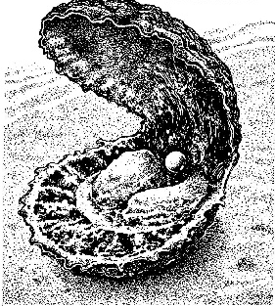
Welcome to Lamb of God Lutheran Church
Welcome in the name of Christ Jesus. As we worship, we pray that you will open your heart in preparation as our Savior comes to us through the word and sacraments. If you are a guest, please sign your name, address and most importantly your phone number in our Guest Book in the entrance and come and worship with us again. If we can be of assistance to you in your spiritual walk through life please let us know.
Communion Practice
Lamb of God celebrates the Lord’s Supper in the confession and glad confidence that, as He says, our Lord gives into our mouths not only bread and wine but His very body and blood to eat and to drink for the forgiveness of sins and to strengthen our union with Him and one another. Our Lord invites to His table those baptized Christians who trust in His words, repent of all sin, and set aside any refusal to forgive and love as He forgives and loves us, that they may show forth His death until He comes. Because those who eat and drink our Lord’s body and blood unworthily do so to their great harm and because Holy Communion is a confession of the faith which is confessed at this altar, any who are not yet instructed, in doubt, or who hold a confession differing from that of this congregation and yet desire to receive the Sacrament, are asked first to speak with the Pastor or an elder. For further study, see Matthew 5:23ff; 10:32ff;18:15-35;26:26-29; 1 Corinthians 11:17-34.
A Special Welcome to Those with Young Children
We are very happy that you are here today, whether this is your first or fiftieth time with us. If you need a little help, please ask. There are many people here at Lamb of God who will lend you a hand.
Here are some suggestions to help make worship with your children easier:
- Relax! Jesus knows that children tend to wiggle and squawk a bit, so please don’t feel embarrassed by it. Your children are welcome at Lamb of God.
- Please dare to sit toward the front, where your children can easily see the pastor, note the colors, embrace the action at the altar, and wonder at the symbols in the great stained-glass windows. What Jesus does here promises to engage them.
- Explain the parts of the Divine Service to your children, encouraging them to chime in on their parts: Amen! Lord have mercy! And with your spirit! I believe! Our Father! All of this belongs to them, too.
- Sing the hymns, pray, and voice the responses. Children learn by following your lead.
- If you have to leave the service with your child, feel free to do so – but please hurry back! Like Jesus, we want your children in the Liturgy, not out (there are soft toys and books in the nursery, and activity sheets with colored pencils in the fellowship hall which can be brought into the worship hall to help engage your child)
- Remember that the way we nurture children in church directly affects the way they respond to the Church, God, and to one another. Let them know that they are at home in this house of worship.
- Please know that while you are caring for your children, the rest of us will be rejoicing in Jesus’ words “Let the little children come to me and do not hinder them, for the kingdom of God belongs to such as these” (Luke 18:16)
We know that your children are a gift to the church, so we will do our best to welcome, smile, encourage, help, and bless you all.
This service is from Divine Service Setting One, beginning on Page 151 of the Lutheran Service Book
PRELUDE 765 God Moves in a Mysterious Way
HYMN OF GATHERING (Short Intro) 818 In Thee Is Gladness
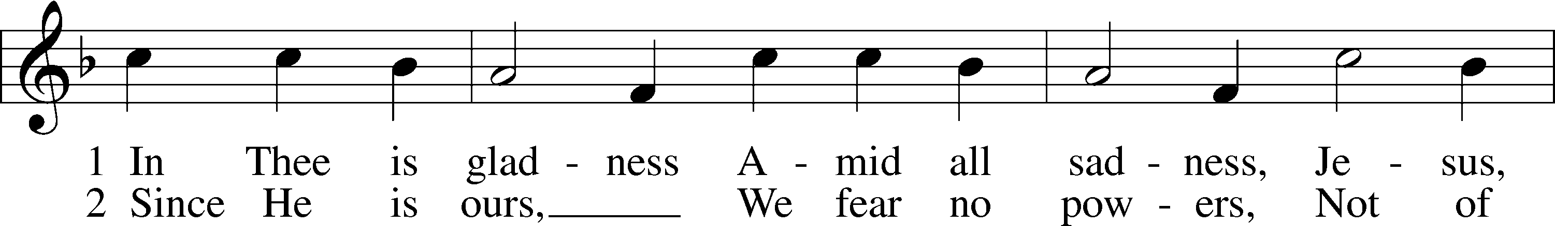
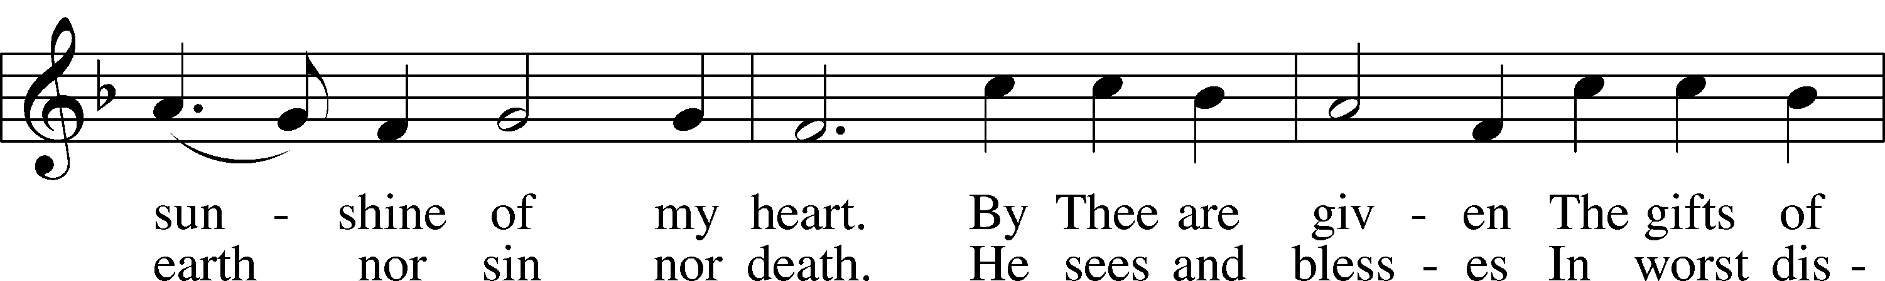
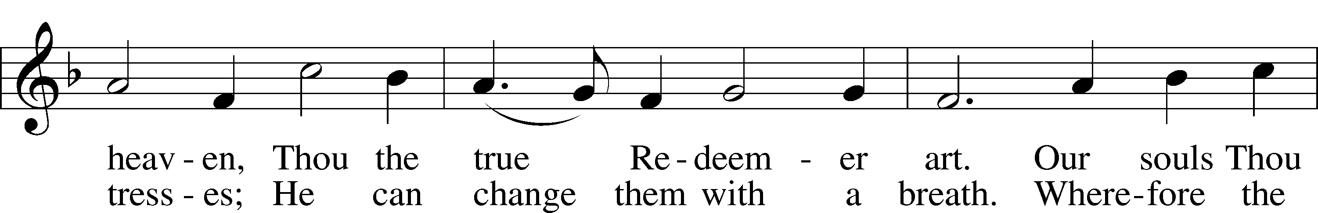
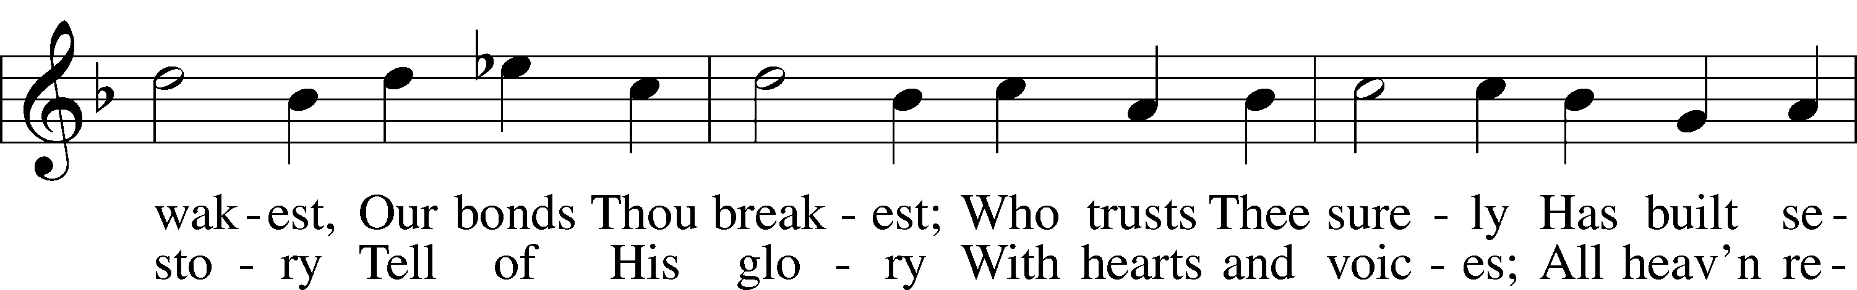
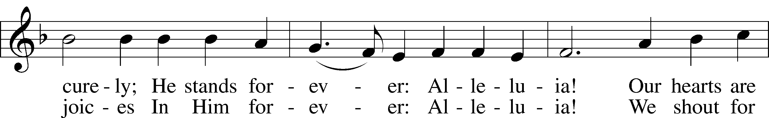
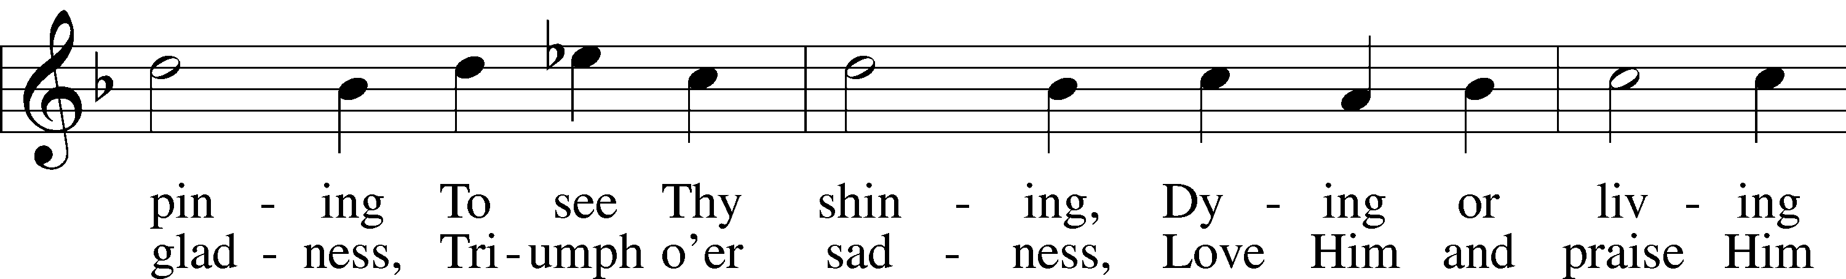
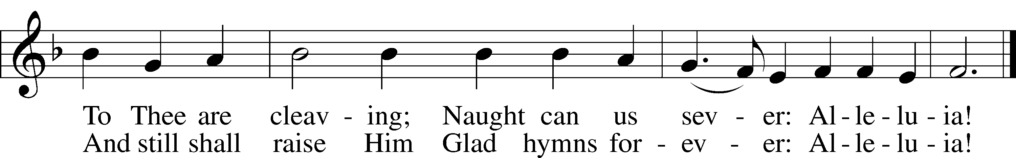
Text: Johann Lindemann, 1549–1631; tr. Catherine Winkworth, 1827–78, alt. Tune: Giovanni Giacomo Gastoldi, c. 1556–c. 1622 Text and tune: Public domain

+ PREPARATION +
INVOCATION Matthew 28:19b; 18:20 LSB 151
P In the name of the Father and of the T Son and of the Holy Spirit.
C Amen.
EXHORTATION 1 John 1:8–9 LSB 151
P If we say we have no sin, we deceive ourselves, and the truth is not in us.
C But if we confess our sins, God, who is faithful and just, will forgive our sins and cleanse us from all unrighteousness.
CONFESSION OF SINS LSB 151
P Let us then confess our sins to God our Father.
C Most merciful God, we confess that we are by nature sinful and unclean. We have sinned against You in thought, word, and deed, by what we have done and by what we have left undone. We have not loved You with our whole heart; we have not loved our neighbors as ourselves. We justly deserve Your present and eternal punishment. For the sake of Your Son, Jesus Christ, have mercy on us. Forgive us, renew us, and lead us, so that we may delight in Your will and walk in Your ways to the glory of Your holy name. Amen.
ABSOLUTION [John 20:19–23] LSB 151
P Almighty God in His mercy has given His Son to die for you and for His sake forgives you all your sins. As a called and ordained servant of Christ, and by His authority, I therefore forgive you all your sins in the name of the Father and of the T Son and of the Holy Spirit.
C Amen.

+ SERVICE OF THE WORD +
INTROIT Psalm 105:2–6; antiphon: v. 1
L Oh give thanks to the Lord; call upon his name;
make known his deeds among the peoples!
C Sing to him, sing praises to him;
tell of all his wondrous works!
Glory in his holy name;
let the hearts of those who seek the Lord rejoice!
Seek the Lord and his strength;
seek his presence continually!
Remember the wondrous works that he has done,
his miracles, and the judgments he uttered,
L O offspring of Abraham, his servant,
children of Jacob, his chosen ones!
C Glory be to the Father and to the Son
and to the Holy Spirit;
as it was in the beginning,
is now, and will be forever. Amen.
L Oh give thanks to the Lord; call upon his name;
make known his deeds among the peoples!
KYRIE Mark 10:47 LSB 152
L In peace let us pray to the Lord.
C Lord, have mercy.
L For the peace from above and for our salvation let us pray to the Lord.
C Lord, have mercy.
L For the peace of the whole world, for the well-being of the Church of God, and for the unity of all let us pray to the Lord.
C Lord, have mercy.
L For this holy house and for all who offer here their worship and praise let us pray to the Lord.
C Lord, have mercy.
L Help, save, comfort, and defend us, gracious Lord.
C Amen.

GLORIA IN EXCELSIS (Short Intro) Luke 2:14; John 1:29 LSB 154
L Glory to God in the Highest, and peace to His people on earth.

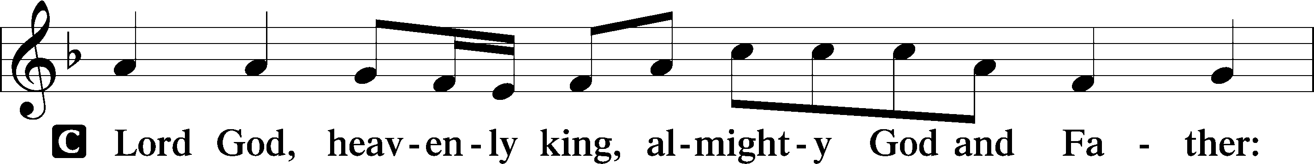
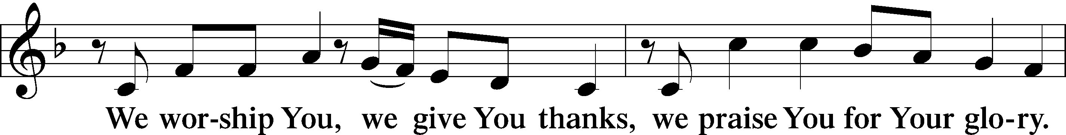
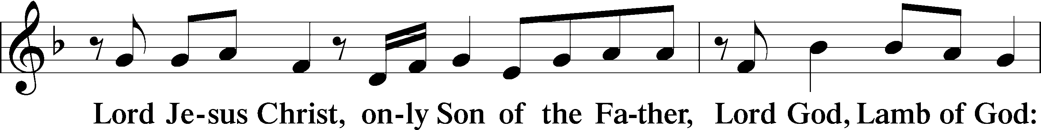
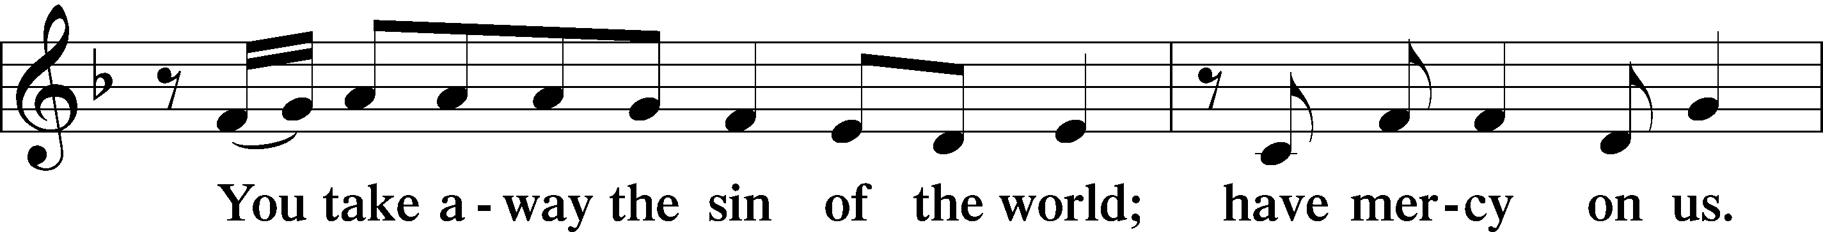
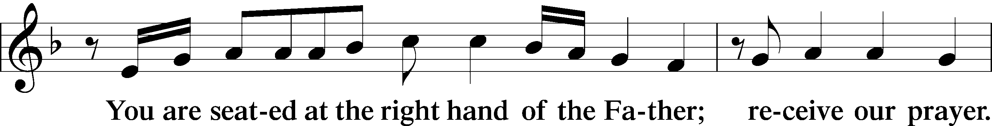
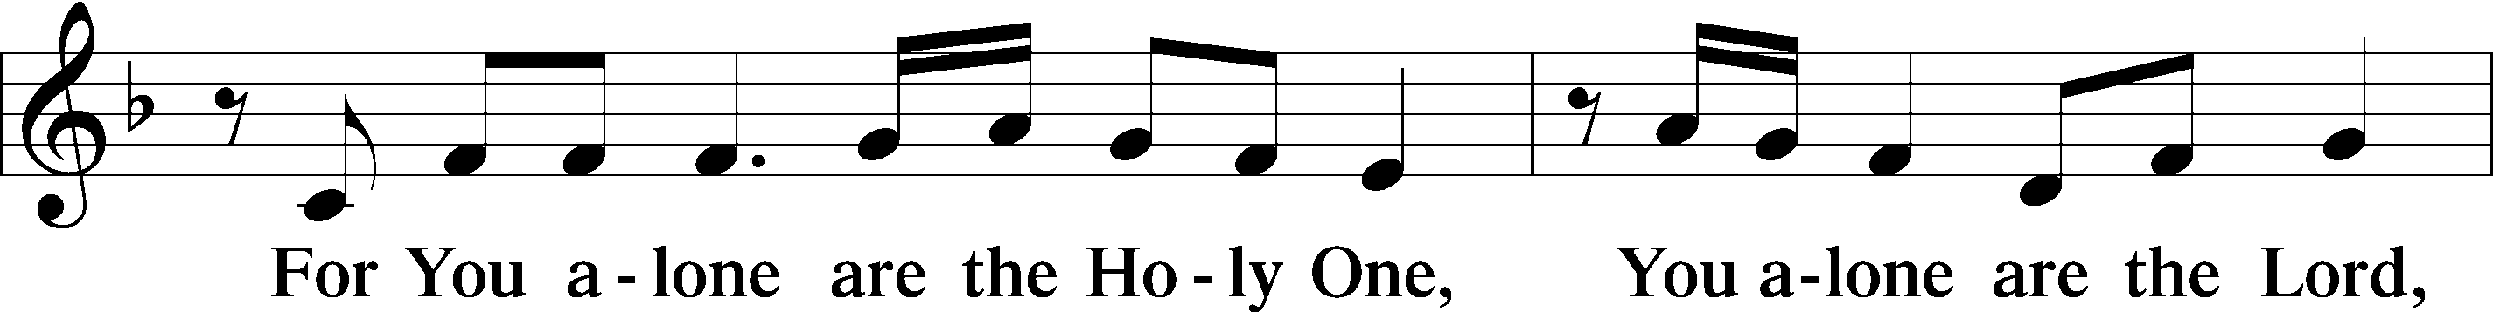
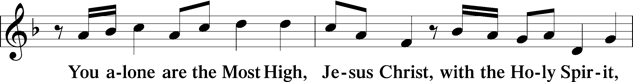
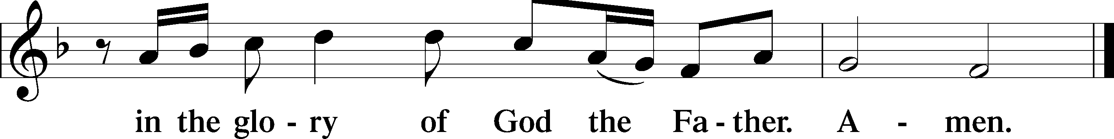

SALUTATION AND COLLECT OF THE DAY 2 Timothy 4:22 LSB 156
P The Lord be with you.
C And also with you.
P Let us pray: Almighty and everlasting God, give us an increase of faith, hope, and love, that, receiving what You have promised, we may love what You have commanded; through Jesus Christ, Your Son, our Lord, who lives and reigns with You and the Holy Spirit, one God, now and forever.
C Amen.
OLD TESTAMENT READING Deuteronomy 7:6–9
L The Old Testament Reading is from Deuteronomy, chapter 7.
6“You are a people holy to the Lord your God. The Lord your God has chosen you to be a people for his treasured possession, out of all the peoples who are on the face of the earth. 7It was not because you were more in number than any other people that the Lord set his love on you and chose you, for you were the fewest of all peoples, 8but it is because the Lord loves you and is keeping the oath that he swore to your fathers, that the Lord has brought you out with a mighty hand and redeemed you from the house of slavery, from the hand of Pharaoh king of Egypt. 9Know therefore that the Lord your God is God, the faithful God who keeps covenant and steadfast love with those who love him and keep his commandments, to a thousand generations.”
L This is the Word of the Lord.
C Thanks be to God.
PSALM Psalm 125; antiphon: v. 2
L 1Those who trust in the Lord are like Mount Zion,
which cannot be moved, but abides forever.
2As the mountains surround Jerusalem,
so the Lord surrounds his people,
from this time forth and forevermore.
3For the scepter of wickedness shall not rest
on the land allotted to the righteous,
lest the righteous stretch out
their hands to do wrong.
4Do good, O Lord, to those who are good,
and to those who are upright in their hearts!
5But those who turn aside to their crooked ways
the Lord will lead away with evildoers!
Peace be upon Israel!

EPISTLE Romans 8:28–39
L The Epistle is from Romans, chapter 8.
28We know that for those who love God all things work together for good, for those who are called according to his purpose. 29For those whom he foreknew he also predestined to be conformed to the image of his Son, in order that he might be the firstborn among many brothers. 30And those whom he predestined he also called, and those whom he called he also justified, and those whom he justified he also glorified.
31What then shall we say to these things? If God is for us, who can be against us? 32He who did not spare his own Son but gave him up for us all, how will he not also with him graciously give us all things? 33Who shall bring any charge against God’s elect? It is God who justifies. 34Who is to condemn? Christ Jesus is the one who died—more than that, who was raised—who is at the right hand of God, who indeed is interceding for us. 35Who shall separate us from the love of Christ? Shall tribulation, or distress, or persecution, or famine, or nakedness, or danger, or sword? 36As it is written,
“For your sake we are being killed all the day long;
we are regarded as sheep to be slaughtered.”
37No, in all these things we are more than conquerors through him who loved us. 38For I am sure that neither death nor life, nor angels nor rulers, nor things present nor things to come, nor powers, 39nor height nor depth, nor anything else in all creation, will be able to separate us from the love of God in Christ Jesus our Lord.
L This is the Word of the Lord.
C Thanks be to God.

ALLELUIA AND VERSE (Short Intro) John 6:68 LSB 156
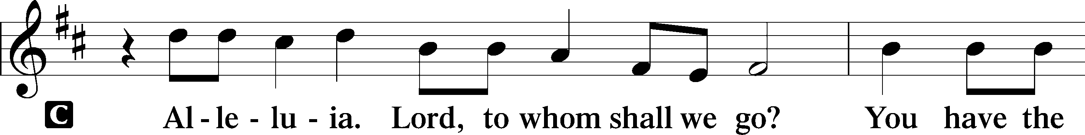
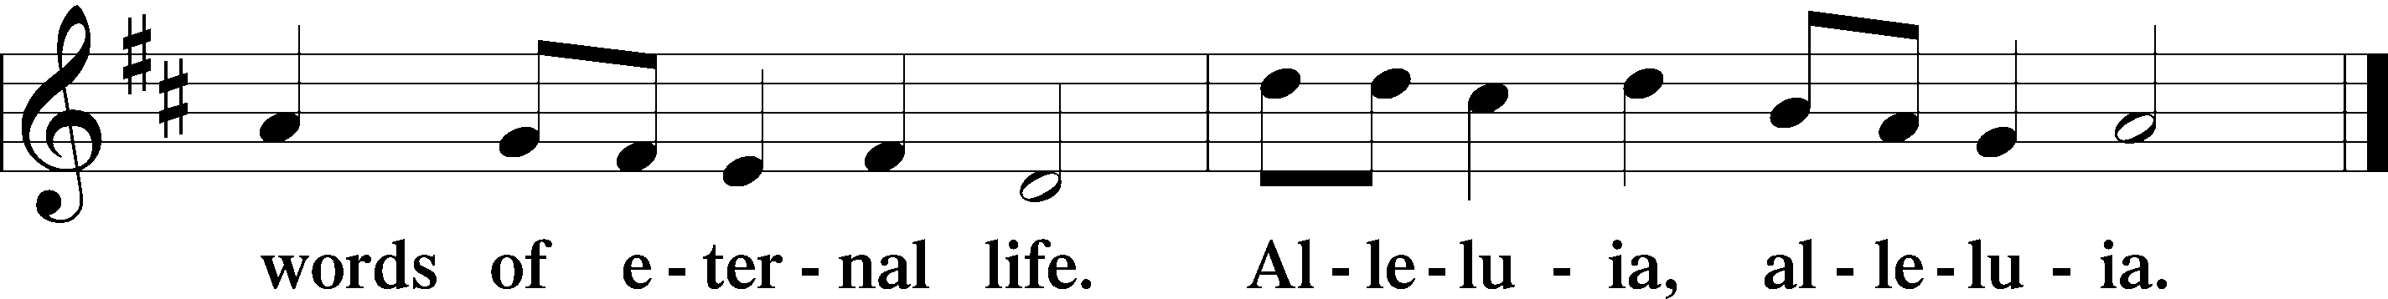
HOLY GOSPEL Matthew 13:44–52
P The Holy Gospel according to St. Matthew, the thirteenth chapter.
C Glory to You, O Lord.
44[Jesus said:] “The kingdom of heaven is like treasure hidden in a field, which a man found and covered up. Then in his joy he goes and sells all that he has and buys that field.
45“Again, the kingdom of heaven is like a merchant in search of fine pearls, 46who, on finding one pearl of great value, went and sold all that he had and bought it.
47“Again, the kingdom of heaven is like a net that was thrown into the sea and gathered fish of every kind. 48When it was full, men drew it ashore and sat down and sorted the good into containers but threw away the bad. 49So it will be at the close of the age. The angels will come out and separate the evil from the righteous 50and throw them into the fiery furnace. In that place there will be weeping and gnashing of teeth.
51“Have you understood all these things?” They said to him, “Yes.” 52And he said to them, “Therefore every scribe who has been trained for the kingdom of heaven is like a master of a house, who brings out of his treasure what is new and what is old.”
P This is the Gospel of the Lord.
C Praise to You, O Christ.

HYMN OF THE DAY (Full Intro) 713 From God Can Nothing Move Me
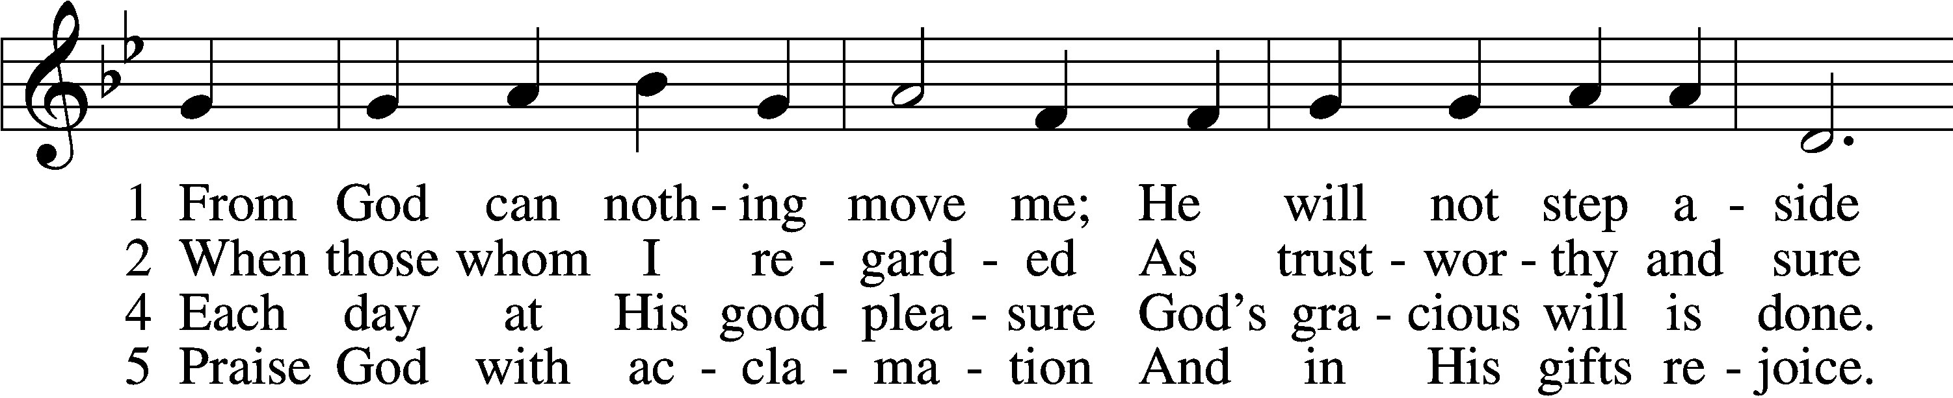
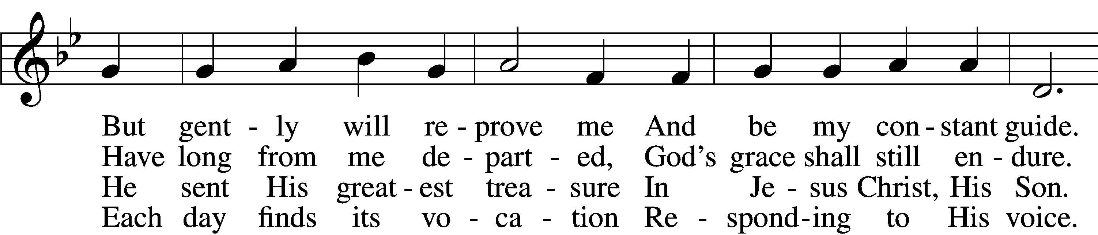
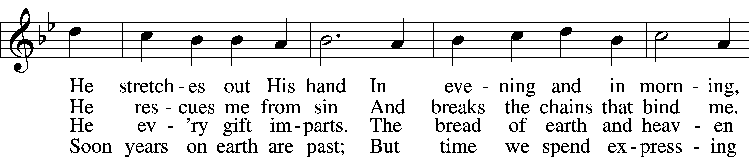
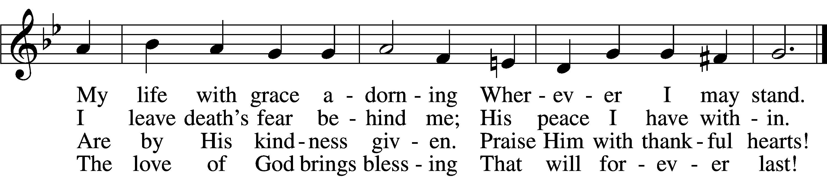
Text: Ludwig Helmbold, 1532–98; (sts. 1–2): tr. Gerald Thorson, 1921–2001, alt.; (sts. 4–5): tr. Gregory J. Wismar, 1946 Tune: Recueil de plusieurs chansons, 1557, Lyons, alt.
Text (sts. 1–2): © 1978 Lutheran Book of Worship; (sts. 4–5): © 2006 Concordia Publishing House. Used by permission: LSB Hymn License no. 110018177 Tune: Public domain

SERMON Pastor Eugene Larmi


CREED Nicene Creed LSB 158
C I believe in one God,
the Father Almighty,
maker of heaven and earth
and of all things visible and invisible.
And in one Lord Jesus Christ,
the only-begotten Son of God,
begotten of His Father before all worlds,
God of God, Light of Light,
very God of very God,
begotten, not made,
being of one substance with the Father,
by whom all things were made;
who for us men and for our salvation came down from heaven
and was incarnate by the Holy Spirit of the virgin Mary
and was made man;
and was crucified also for us under Pontius Pilate.
He suffered and was buried.
And the third day He rose again according to the Scriptures
and ascended into heaven
and sits at the right hand of the Father.
And He will come again with glory to judge both the living and the dead,
whose kingdom will have no end.
And I believe in the Holy Spirit,
the Lord and giver of life,
who proceeds from the Father and the Son,
who with the Father and the Son together is worshiped and glorified,
who spoke by the prophets.
And I believe in one holy Christian and apostolic Church,
I acknowledge one Baptism for the remission of sins,
and I look for the resurrection of the dead
and the life T of the world to come. Amen.

PRAYER OF THE CHURCH
P Let us pray for the whole Church of God in Christ Jesus and for all people according to their needs.
O Lord, preserve us from error and deliver us from temptation. Grant that we may abide in Christ and His word of truth, remaining steadfast and immovable until the end. Lord, in Your mercy,
C hear our prayer.
P O God, You send out pastors to preach and teach the whole counsel of Your Word. Grant that they may serve You faithfully, and that we may receive their words with joy and thanksgiving. Lord, in Your mercy,
C hear our prayer.
P Heavenly Father, You have given us various offices in our lives. Grant us faithfulness in these callings, that we may see them as gifts through which we serve You and our neighbors. Lord, in Your mercy,
C hear our prayer.
P Holy Lord, grant wisdom to Donald, our president; Dan our governor; and all who make, administer and judge our laws, that they may seek what is best for all in accordance with Your will. Lord, in Your mercy,
C hear our prayer.
P Merciful Lord, grant that all who commune today might receive the Sacrament faithfully and depart refreshed, knowing that they are Your forgiven people. Lord, in Your mercy,
C hear our prayer.
P Gracious God, we know that neither life nor death can separate us from Your love in Christ Jesus, our Lord. We thank You for all who have fallen asleep in the hope of the resurrection, and we ask You to grant us also our inheritance with the saints in light. Lord, in Your mercy,
C hear our prayer.
P Almighty God, bestow Your comfort on all who are burdened by sickness and affliction [especially ___]. Grant that they may await healing and deliverance in the firm conviction that nothing can separate them from Your love in Christ Jesus. Lord, in Your mercy,
C hear our prayer.
P These and whatsoever other things You would have us ask of You, O God, grant us for the sake of Jesus Christ, Your only Son, our Lord and Savior, who lives and reigns with You and the Holy Spirit, one God, now and forever.
C Amen.

OFFERING Offering Plates are Passed by Ushers
Please enter your attendance in the red Record of Fellowship
OFFERTORY (Short Intro) Psalm 116:12-13, 17-19 LSB p 159
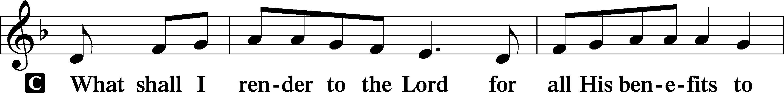
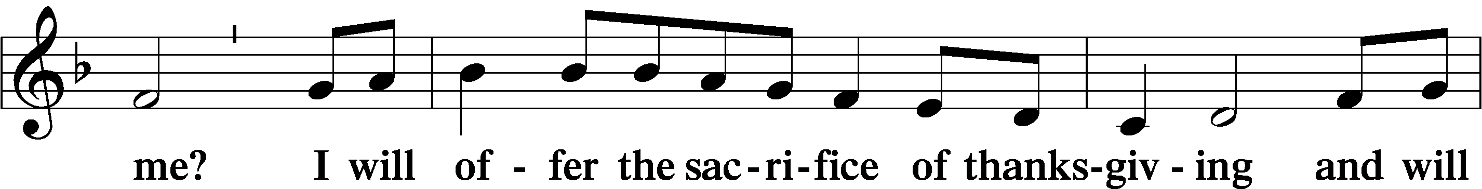
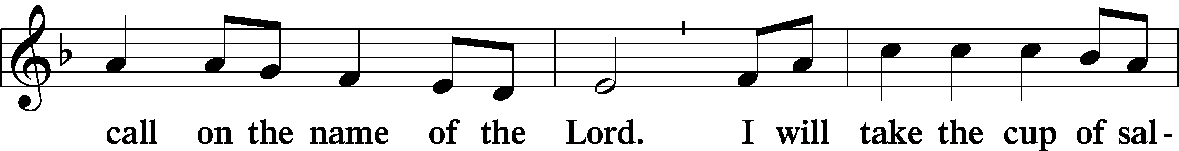
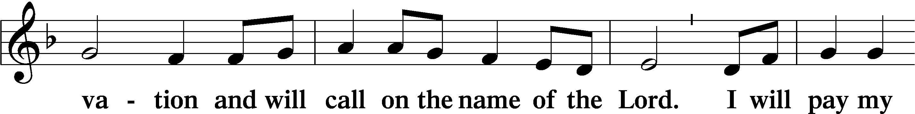
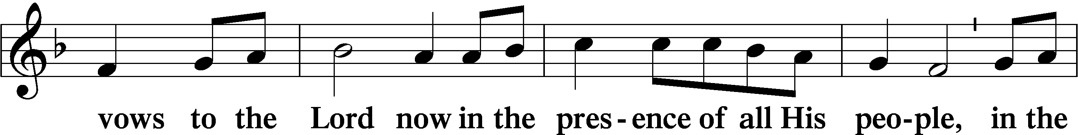
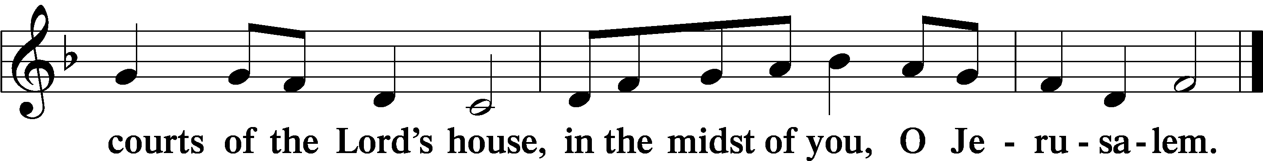
PREPARATION FOR SACRAMENT
Matthew 5:23-24
²³So if you are offering your gift at the altar and there remember that your brother has something against you, ²⁴leave your gift there before the altar and go. First be reconciled to your brother, and then come and offer your gift.
1 Corinthians 11:27-28
²⁷Whoever, therefore, eats the bread or drinks the cup of the Lord in an unworthy manner will be guilty of profaning the body and blood of the Lord. ²⁸Let a person examine himself, then, and so eat of the bread and drink of the cup.

+ SERVICE OF THE SACRAMENT +
PREFACE 2 Timothy 4:22, Colossians 3:1, Psalm 1:36 LSB p 160
P The Lord be with you.
C And also with you.
P Lift up your hearts.
C We lift them to the Lord.
P Let us give thanks to the Lord our God.
C It is right to give Him thanks and praise.
PROPER PREFACE
P It is truly good, right, and salutary that we should at all times and in all places give thanks to You, holy Lord, almighty Father, everlasting God, through Jesus Christ, our Lord. Therefore with angels and archangels and with all the company of heaven we laud and magnify Your glorious name, evermore praising You and saying:
SANCTUS (No Intro) Isaiah 6:3; Matthew 21:9 LSB p161
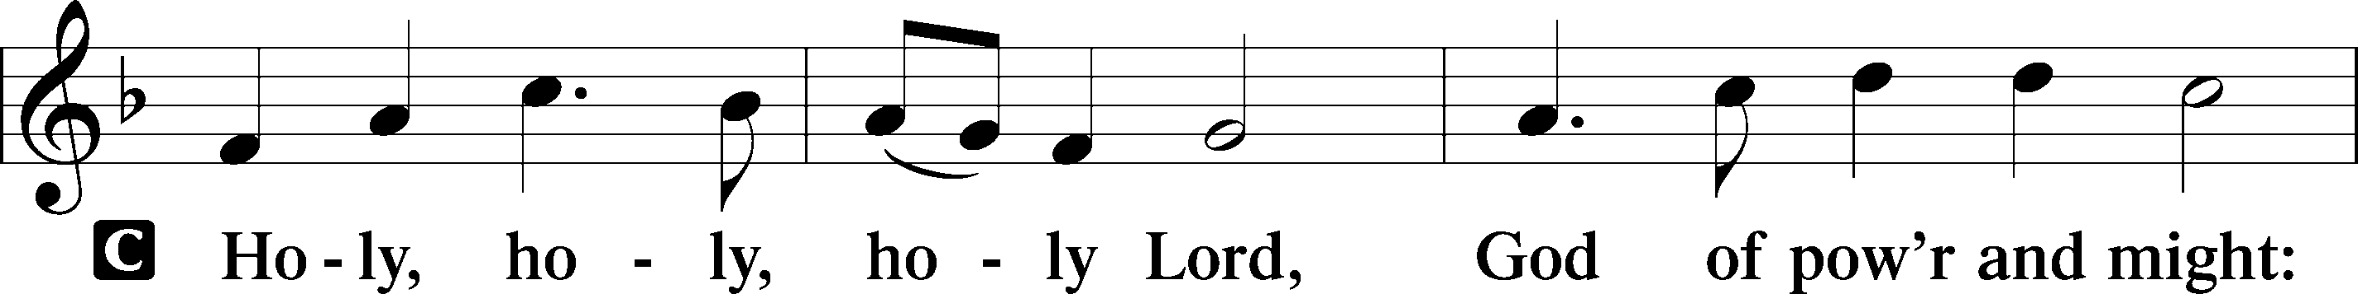
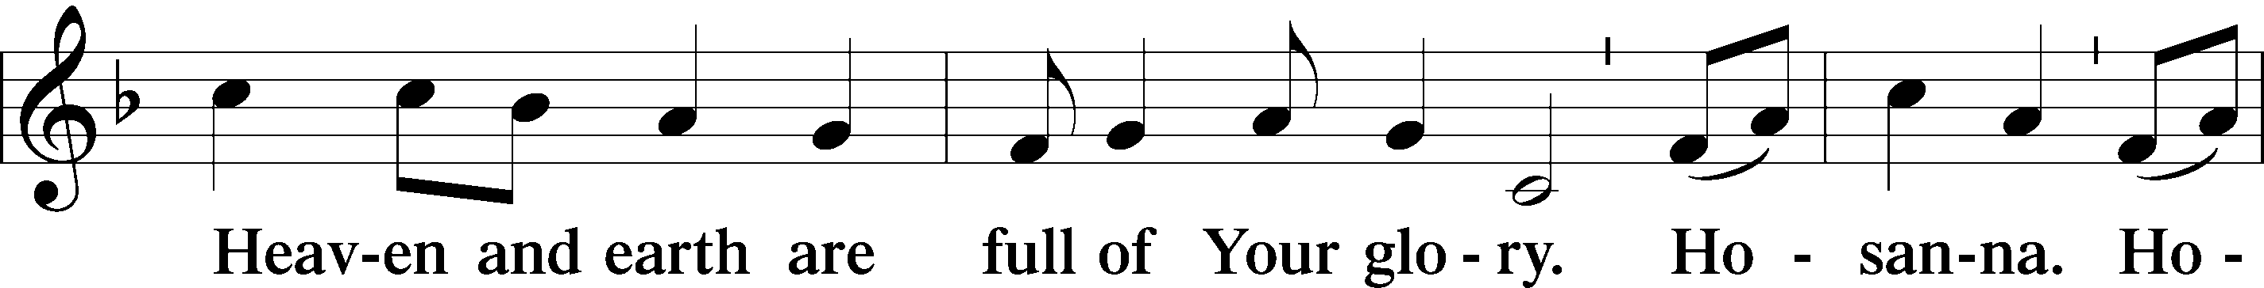
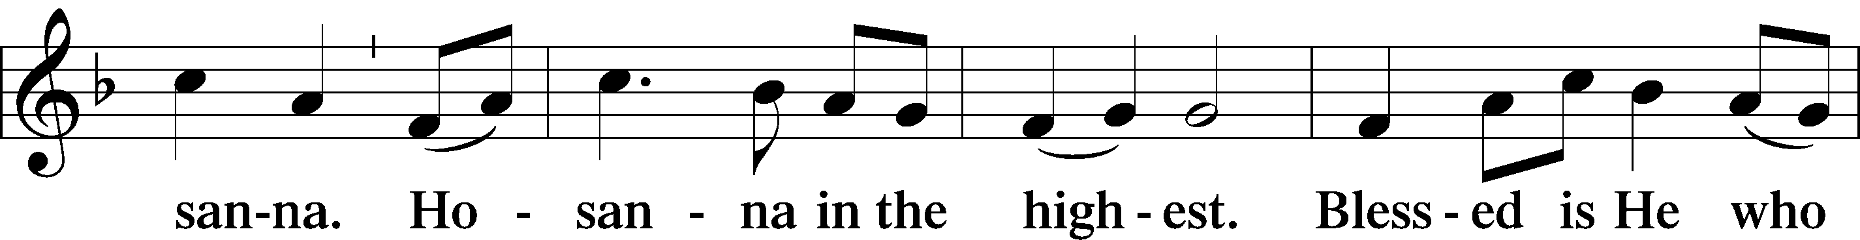
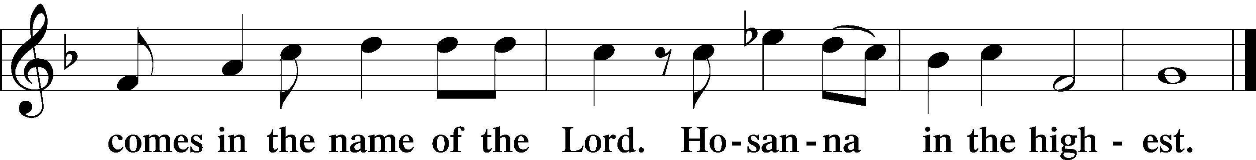

PRAYER OF THANKSGIVING LSB p161
P Blessed are You, Lord of heaven and earth, for You have had mercy on those whom You created and sent Your only-begotten Son into our flesh to bear our sin and be our Savior. With repentant joy we receive the salvation accomplished for us by the all-availing sacrifice of His body and His blood on the cross.
Gathered in the name and the remembrance of Jesus, we beg You, O Lord, to forgive, renew, and strengthen us with Your Word and Spirit. Grant us faithfully to eat His body and drink His blood as He bids us do in His own testament. Gather us together, we pray, from the ends of the earth to celebrate with all the faithful the marriage feast of the Lamb in His kingdom, which has no end. Graciously receive our prayers; deliver and preserve us. To You alone, O Father, be all glory, honor, and worship, with the Son and the Holy Spirit, one God, now and forever.
C Amen.
THE WORDS OF OUR LORD
Matthew 26:26-28; Mark 14:22-24; Luke 22:19-20; 1 Corinthians 11:23-25 LSB 162
P Our Lord Jesus Christ, on the night when He was betrayed, took bread, and when He had given thanks, He broke it and gave it to the disciples and said: “Take, eat; this is My T body, which is given for you. This do in remembrance of Me.”
In the same way also He took the cup after supper, and when He had given thanks, He gave it to them, saying: “Drink of it, all of you; this cup is the new testament in My T blood, which is shed for you for the forgiveness of sins. This do, as often as you drink it, in remembrance of Me.”
PROCLAMATION OF CHRIST

P As often as we eat this bread and drink this cup, we proclaim the Lord’s death until He comes.
C Amen. Come, Lord Jesus.
P O Lord Jesus Christ, only Son of the Father, in giving us Your body and blood to eat and to drink, You lead us to remember and confess Your holy cross and passion, Your blessed death, Your rest in the tomb, Your resurrection from the dead, Your ascension into heaven, and Your coming for the final judgment. So remember us in Your kingdom and teach us to pray:
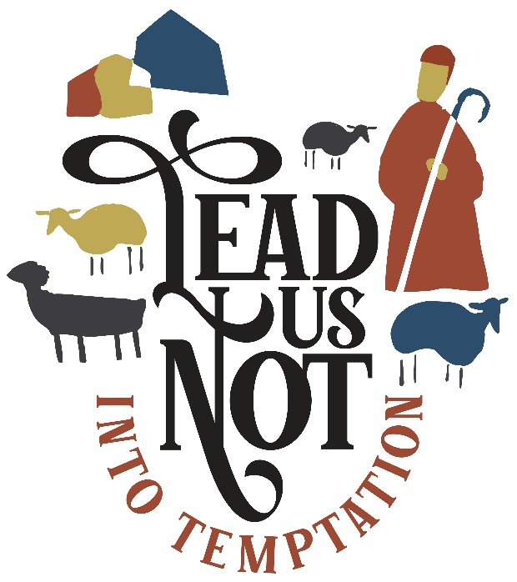
LORD’S PRAYER Matthew 6:9–13 LSB p 162
C Our Father who art in heaven,
hallowed be Thy name,
Thy kingdom come,
Thy will be done on earth
as it is in heaven;
give us this day our daily bread;
and forgive us our trespasses
as we forgive those
who trespass against us;
and lead us not into temptation,
but deliver us from evil.
For Thine is the kingdom
and the power and the glory
forever and ever. Amen.
PAX DOMINI John 20:19 LSB 163
P The peace of the Lord be with you always.
C Amen.
AGNUS DEI (No Intro) John 1:29 LSB p 163
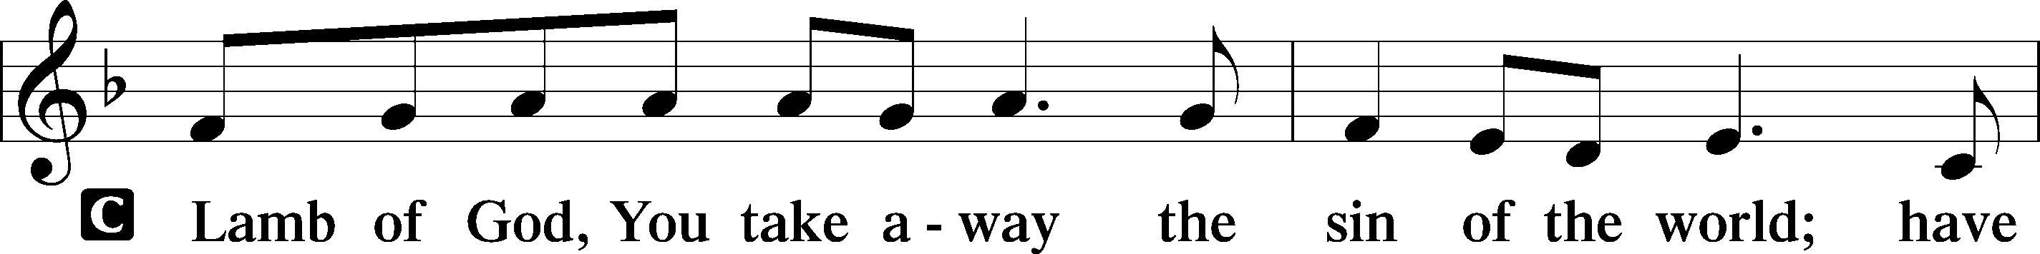
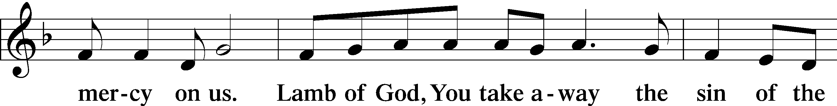
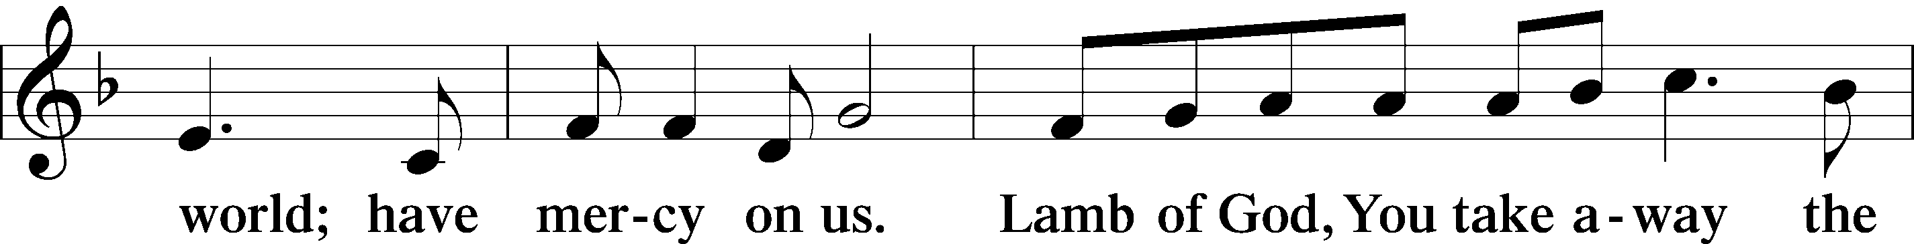
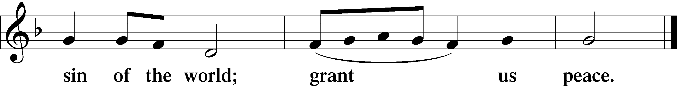

DISTRIBUTION HYMN (Short Intro) 752 Be Still, My Soul
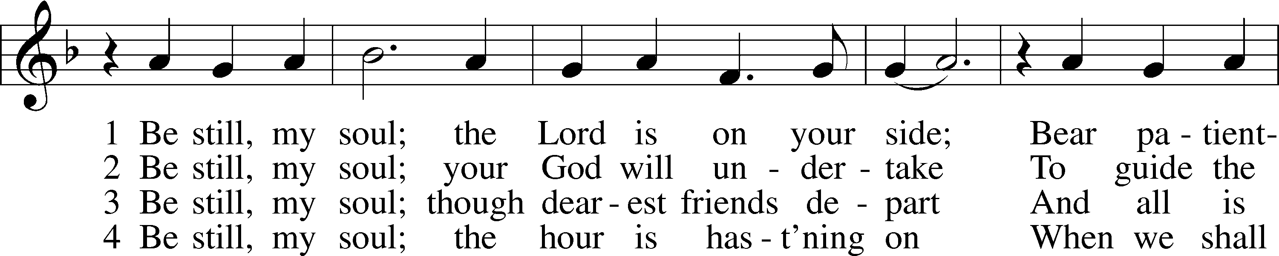
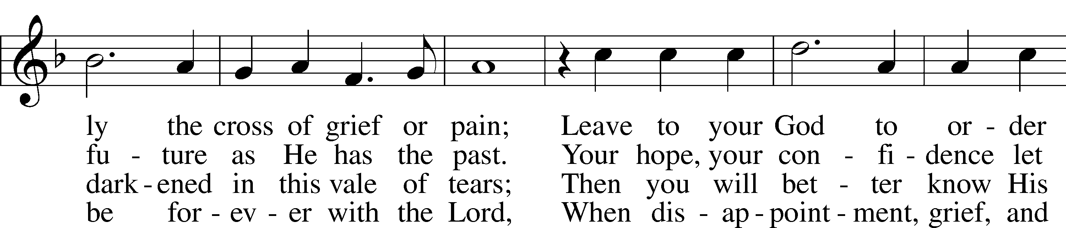
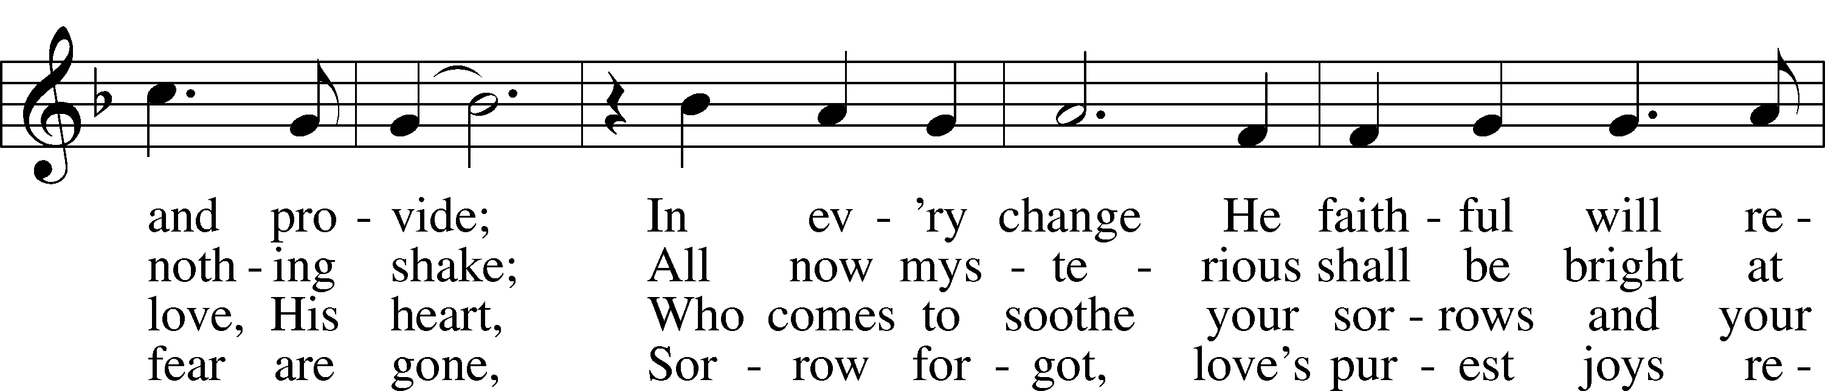
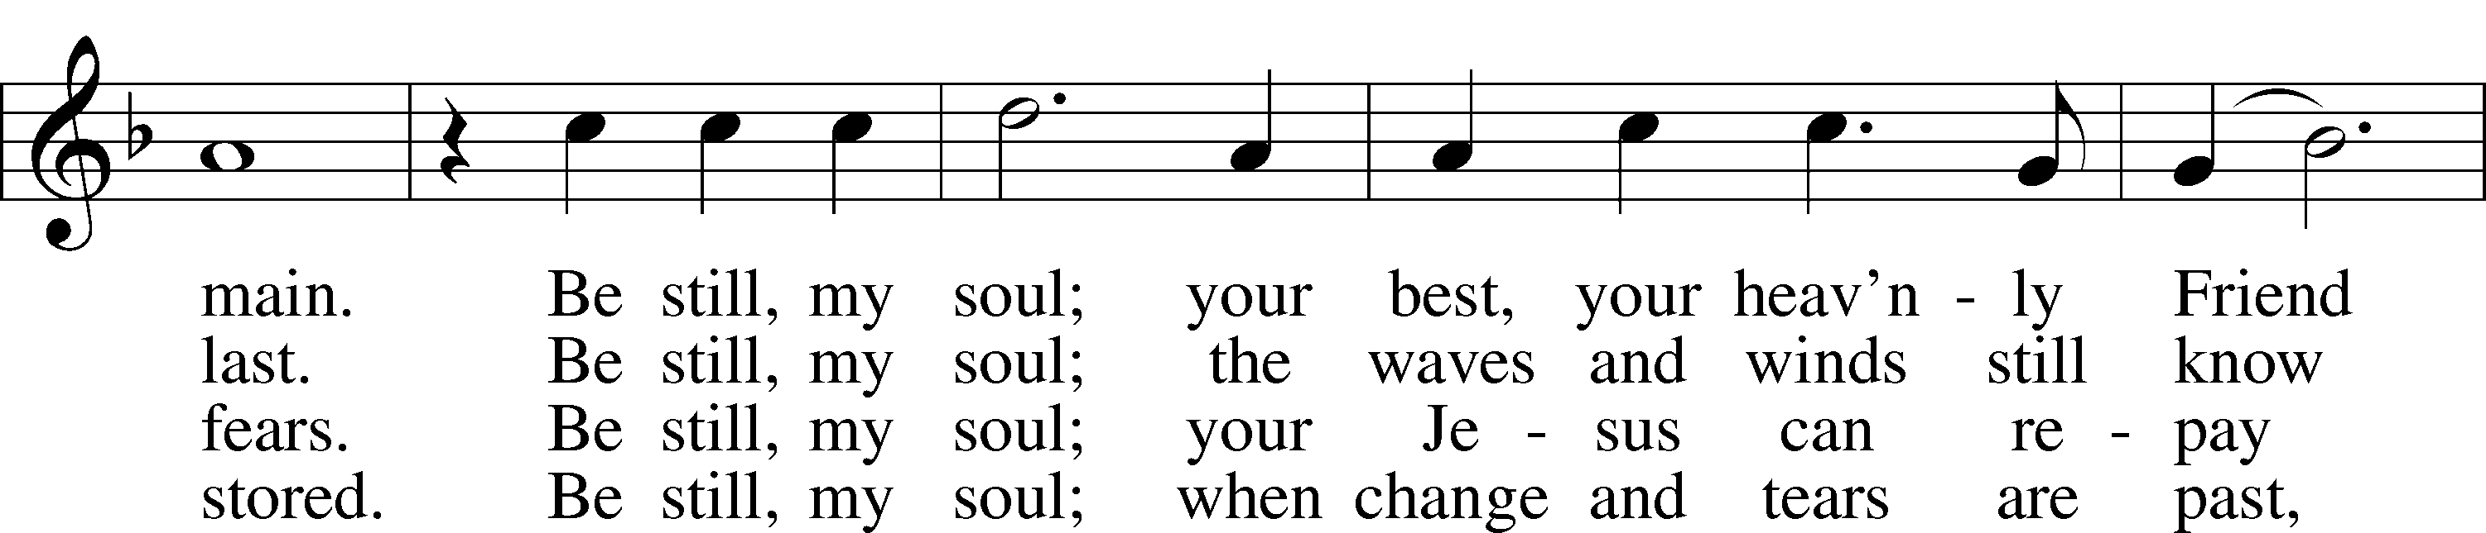
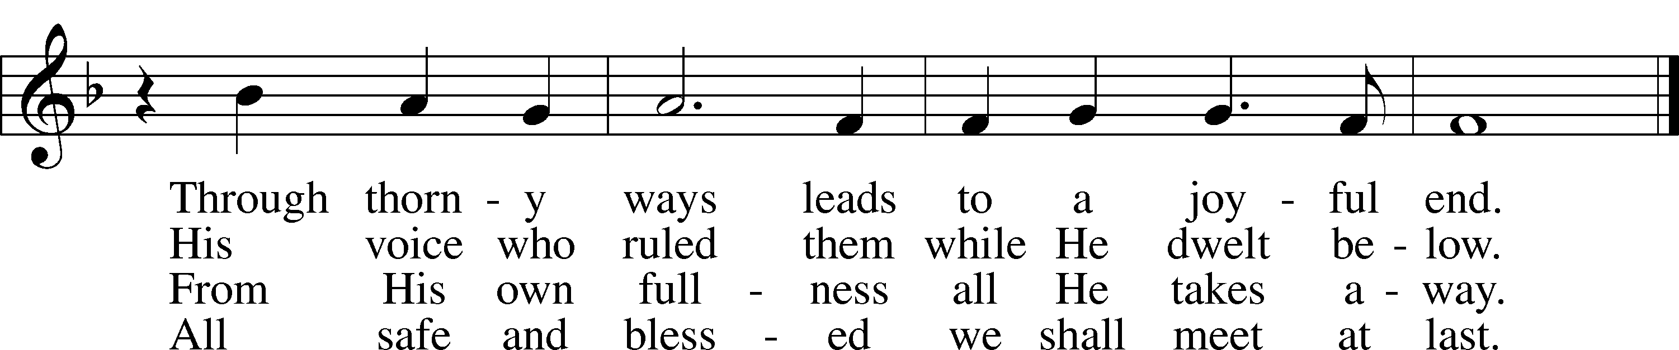
Text: Catharina Amalia Dorothea von Schlegel, 1697–1752; tr. Jane L. Borthwick, 1813–97, alt. Tune: Jean Sibelius, 1865–1957, adapt. Text and tune: Public domain

Be still, my soul; the Lord is on your side;
DISTRIBUTION HYMN (Refrain Intro) 619 Thy Body, Given for Me, O Savior
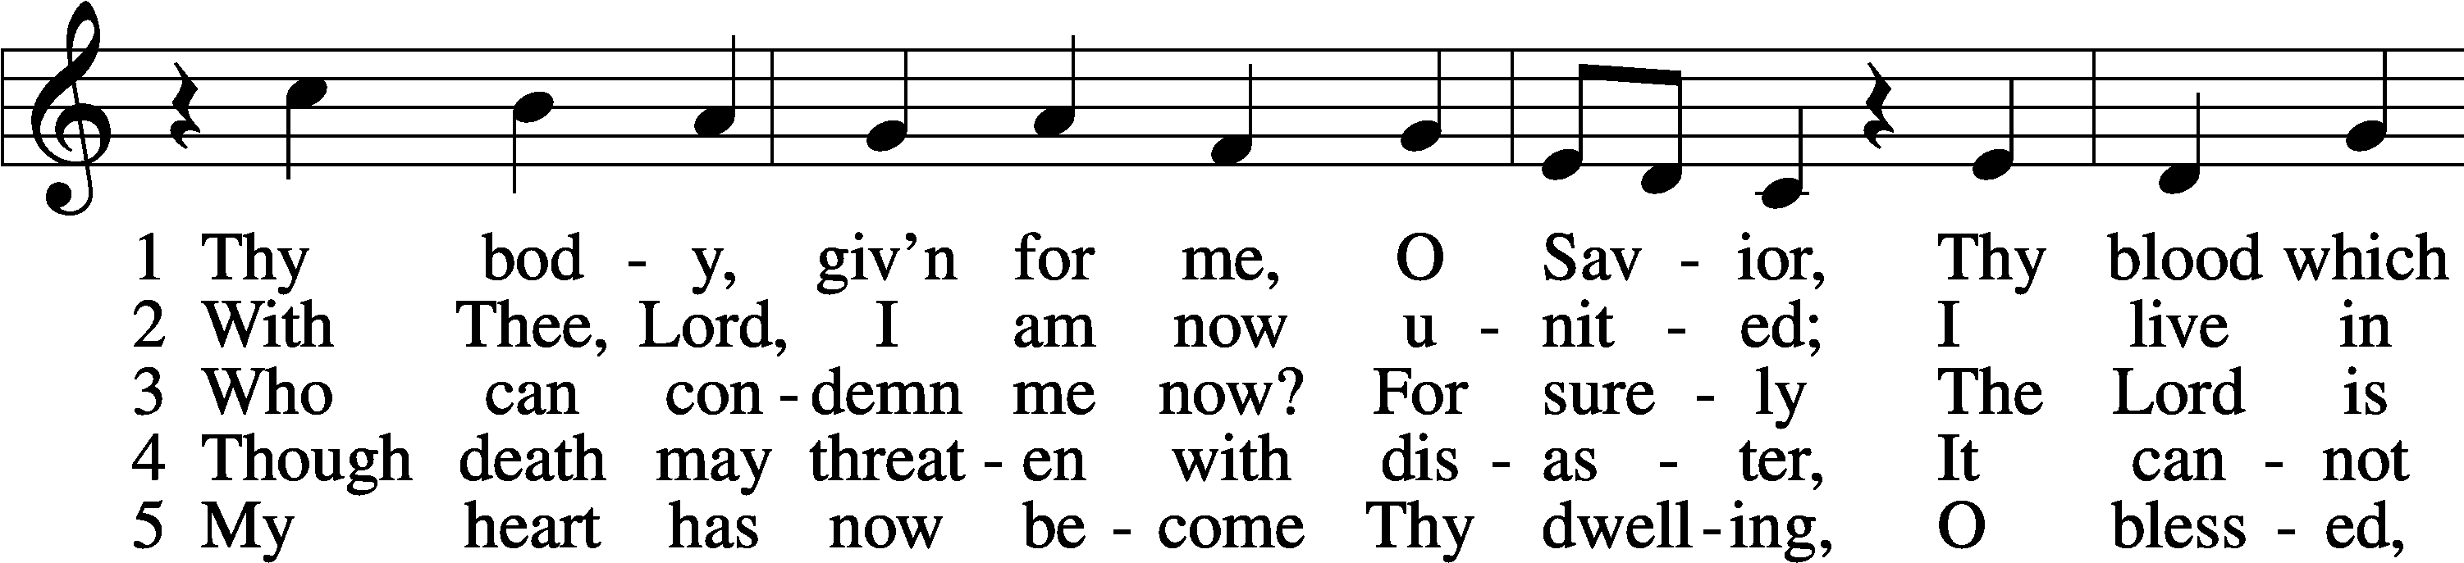
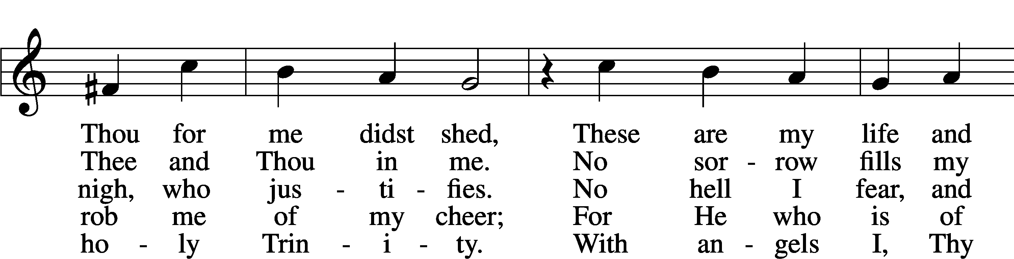
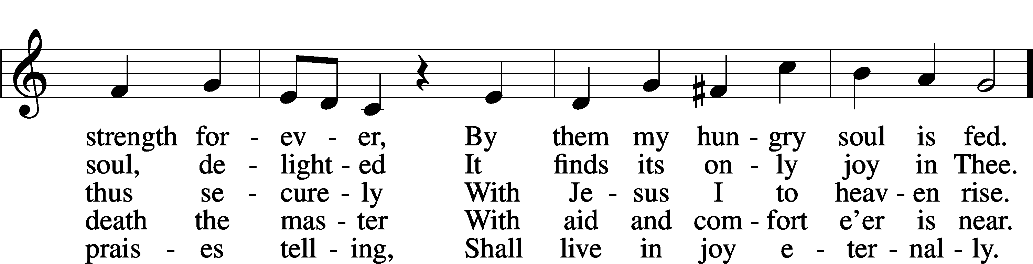
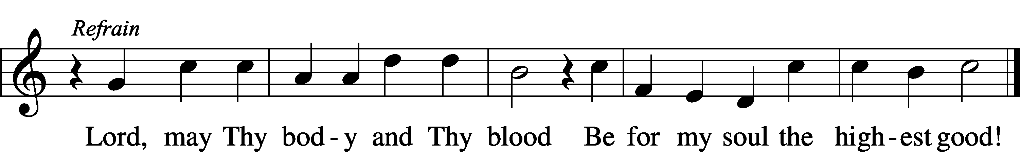
Text: Friedrich Christian Heyder, 1677–1754; tr. The Lutheran Hymnal, 1941, abr. Tune: Emskirchner Choral-Buch, 1756, Leipzig
Text: © 1941 Concordia Publishing House. Used by permission: LSB Hymn License no. 110018177 Tune: Public domain

DISTRIBUTION HYMN (Refrain Intro) 763 When Peace, like a River
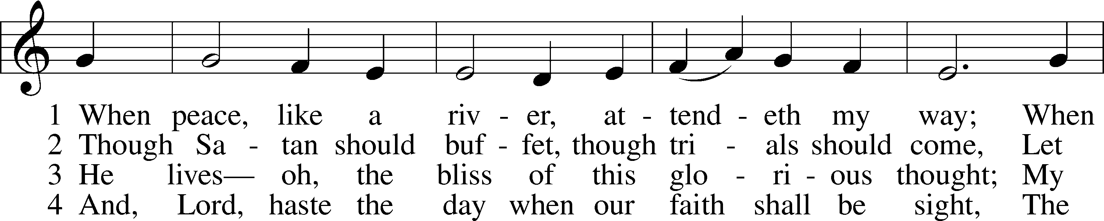
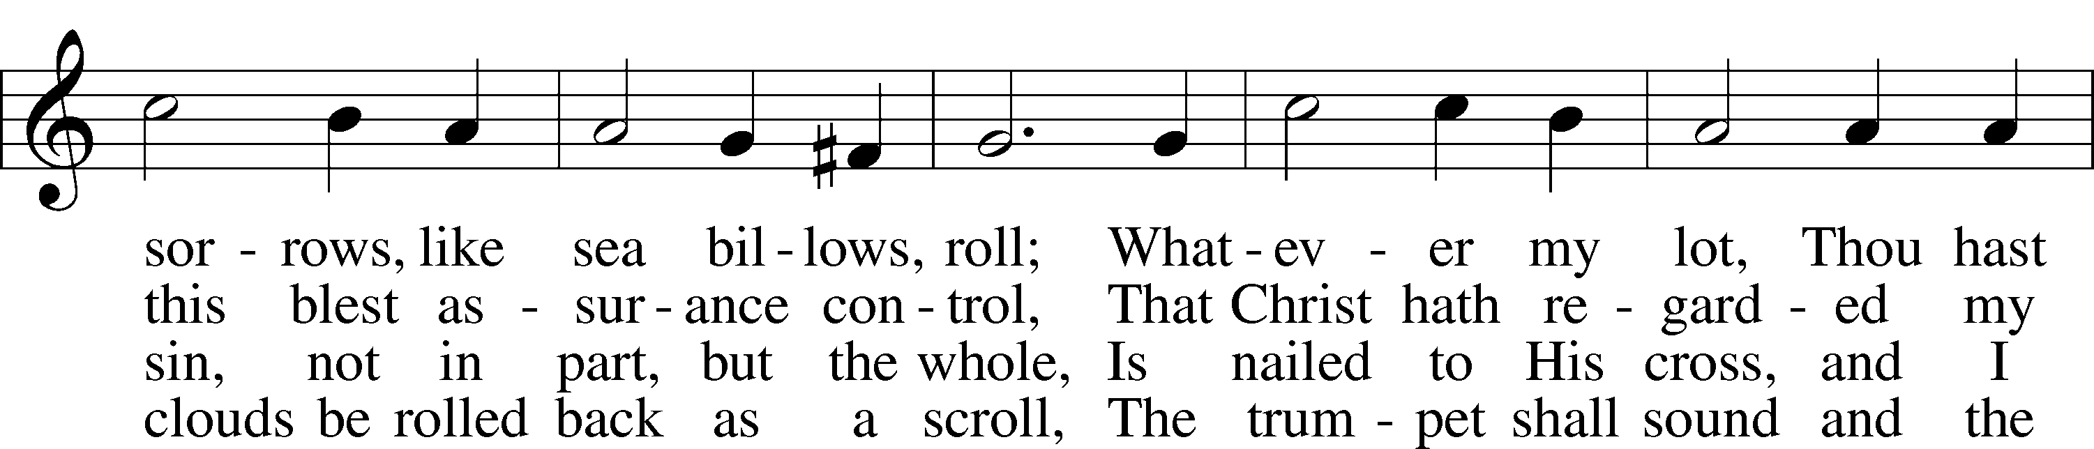
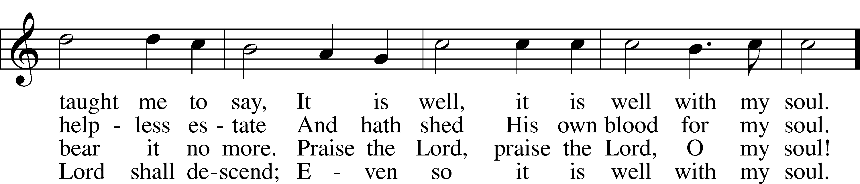
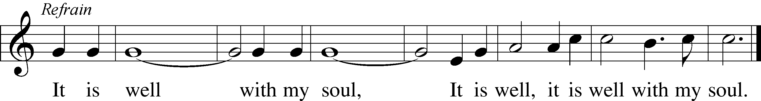
Text: Horatio G. Spafford, 1828–88, alt. Tune: Philip P. Bliss, 1838–76 Text and tune: Public domain

THANK THE LORD (Short Intro) [Psalm 105:1-3, 42-43]; [1 Chronicles 16:8-10 LSB 164
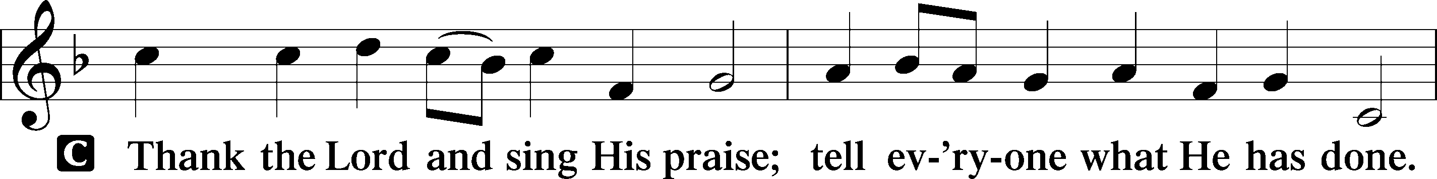
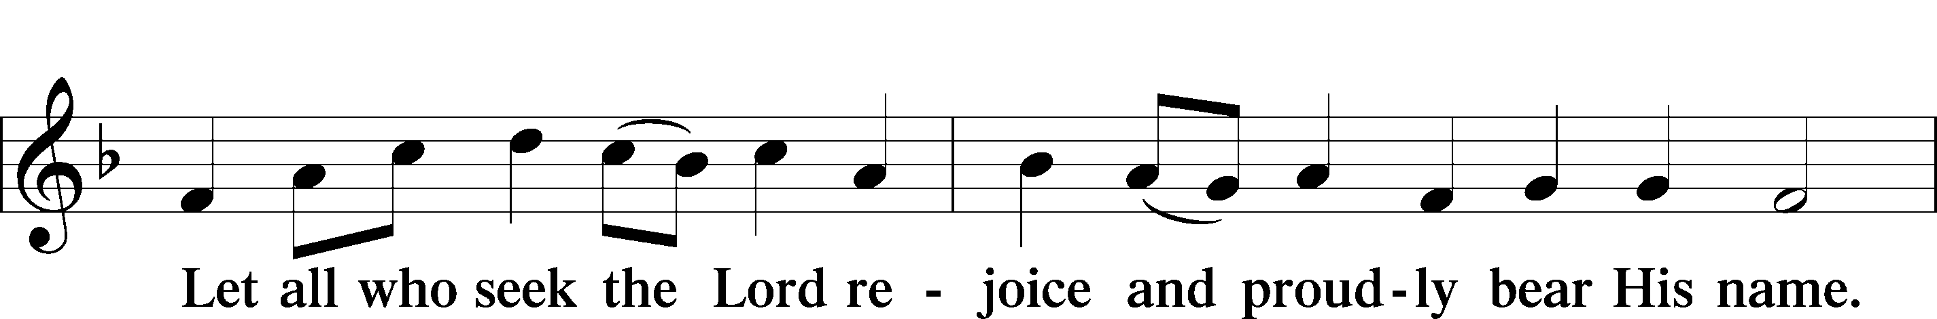
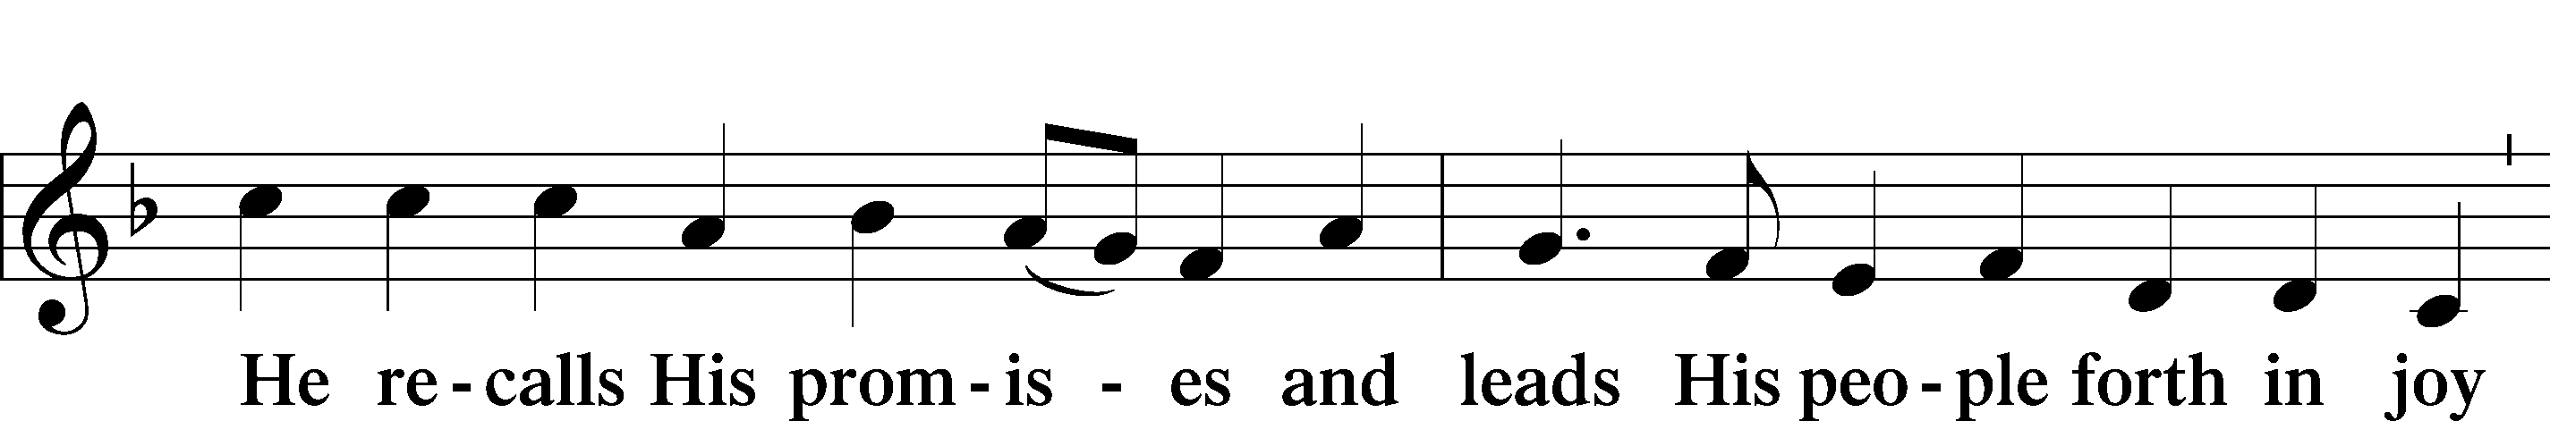
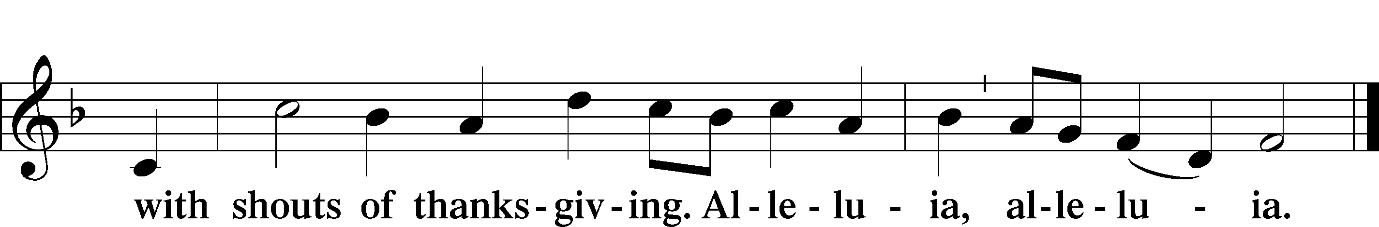
POST-COMMUNION COLLECT LSB p. 166
P Let us pray.: We give thanks to You, almighty God, that You have refreshed us through this salutary gift, and we implore You that of Your mercy You would strengthen us through the same in faith toward You and in fervent love toward one another; through Jesus Christ, Your Son, our Lord, who lives and reigns with You and the Holy Spirit, one God, now and forever.
C Amen.
ANNOUNCEMENTS
BENEDICTION Numbers 6:24-26 LSB p 166
P The Lord bless you and keep you.

The Lord make His face shine on you and be gracious to you.
The Lord look upon you with favor and T give you peace.
C Amen.

DISMISSAL HYMN (Full Intro) 924 Lord, Dismiss Us with Your Blessing
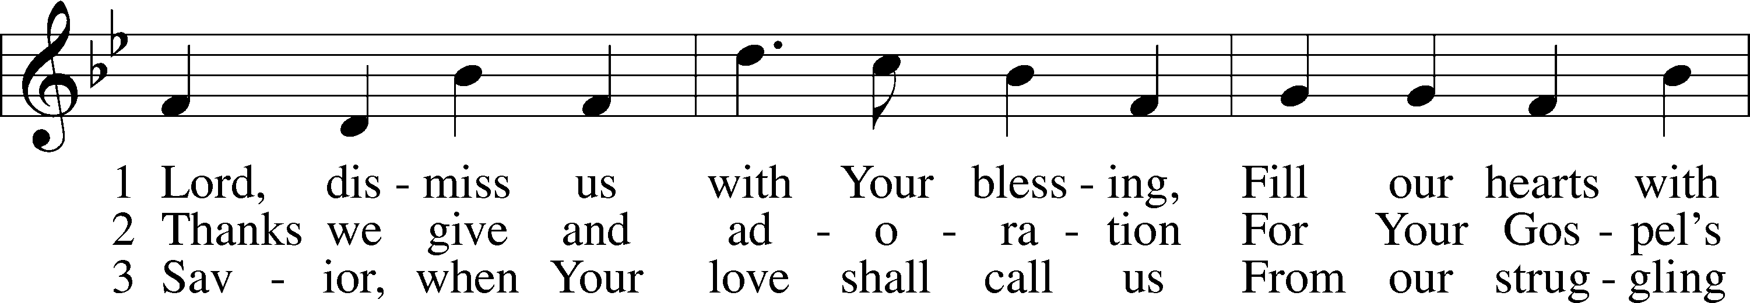
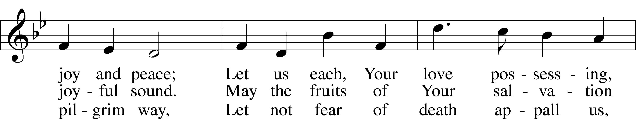
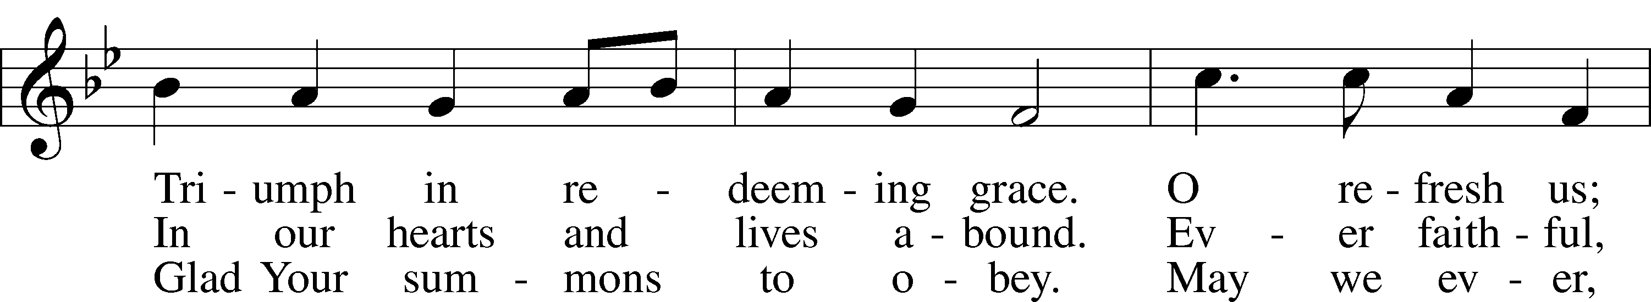
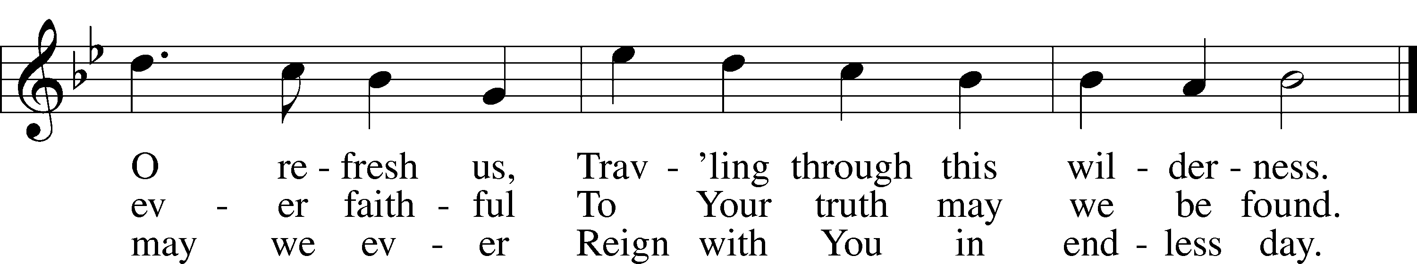
Text (sts. 1–2): attr. John Fawcett, 1740–1817, alt.; (st. 3): Godfrey Thring, 1823–1903, alt. Tune: Henry T. Smart, 1813–79 Text and tune: Public domain

DISMISSAL
P Go in peace as you serve the Lord.
C Thanks be to God! Alleluia, Amen!
POSTLUDE 760 What God Ordains Is Always Good
ACKNOWLEDGMENTS: Divine Service, Setting One from Lutheran Service Book. Unless otherwise indicated, Scripture quotations are from the ESV® Bible (The Holy Bible, English Standard Version®), copyright © 2001 by Crossway, a publishing ministry of Good News Publishers. Used by permission. All rights reserved. Created by Lutheran Service Builder © 2026 Concordia Publishing House.

